**DELHI TECHNOLOGICAL UNIVERSITY**

**ECONOMICS ASSIGNMENT**

**Sustainable Development Goals**

**Under supervision of: PROFESSOR SEEMA SINGH(Dept. of Humanities)**

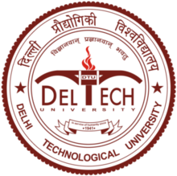

**Submitted by :**

**PRAJJWAL CHITTORI (2K18/CO/249)**

**PRANAV ROY (2K18/CO/250)**

**(Dept. of Computer Science and Engineering)**

Detail of Assignment

|  |  |  |
| --- | --- | --- |
| **S no.** | **Details** | **Page no.** |
| **1.** | **Introduction** |  |
| **2.** | **Purpose/Objective** |  |
| **3.** | **Design/Methodology/Approach** |  |
| **4.** | **Findings** |  |
| **5.** | **Implications** |  |
| **6.** | **Limitations** |  |
| **7.** | **Originality Value** |  |
| **8.** | **Reference** |  |

**Introduction:**

Sustainable development can be defined as development that meets the needs of the present without compromising the ability of future generations to meet their own needs.

Sustainable development is a concept that appeared for the first time in 1987 with the publication of the Brundtland report warning of the negative environmental consequences of economic growth and globalization, which tried to find possible solutions to the problems caused by industrialization and population growth.

Sustainable development is the organizing principle for meeting human development goals while simultaneously sustaining and preserving the natural resources and ecosystem.

Sustainable development has shifted its focus more towards the economic development, social development and environmental protection for future generations.

Sustainability' should be viewed as humanity's target goal of human-ecosystem equilibrium while 'sustainable development' refers to the holistic approach and temporal processes that lead us to the end point of sustainability".

**Purpose/Objective**

The word "sustainability" is derived from the Latin origin "sustinere". Dictionaries provide more than ten meanings for sustain, the main ones being to "maintain", "support" or "endure". Sustainability is the capability of being supported or maintained or kept going. A sustainable system is that which maintains its own viability by using techniques that allow for continual reuse. A sustainable development is that which is capable of being maintained at steady state level without exhausting natural resources or causing severe ecological damage.

Sustainability may be considered as the capacity to endure. For humans, sustainability is the long-term maintenance of responsibility, which has environmental, economic and social dimensions and encompasses the concept of stewardship, the responsible management of resource use. In ecology, sustainability describes how biological systems remain diverse and productive over time, a necessary precondition for the well-being of humans and other organisms. Long-lived and healthy wetlands and forests are examples of sustainable biological systems

The Bruntland's definition has attained universal traction and is seen by many who recognize the current unsustainable nature of society as a means of achieving sustainability. For example, the Royal Academy of Engineering published guiding principles on energy for sustainable development in 2005, to address the problem that, "we are exceeding the capacity of the planet to provide many of the resources we used and to accommodate our emissions, while many of the planet's inhabitants cannot meet even their most basic needs”.

This abstract aim to provide a conceptual framework setting out the connections between engineering projects and the sustainable development of environmental and social systems. The main principles of sustainable development on the one hand and of sustainable engineering on the other hand are first reviewed and summarized. Particular attention is paid to the principles put forward by international and national engineering organizations. Second, concepts and models originating in natural and social sciences are outlined to shed more light on the ways the various aspects of sustainability are related. The conceptual framework we propose combines the reviewed principles, concepts and models in a relevant manner for engineering projects. Engineering and physical or social systems prove to be related in manifold ways. While the most common relations are exposed in the sustainability framework, others have to be further elaborated in order to fully take into account the specificities of the various fields of engineering. Finally, applications of the sustainability framework in engineering 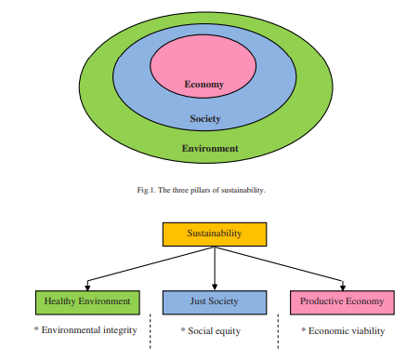practice and engineering education are discussed.

Lastly, Sustainable development involves achieving objectives in three realms: ecological (sustainable scale), economic (efficient allocation) and social (just distribution). While movement toward a sustainable society is dependent upon satisfying all three objectives, questions of just distribution and other questions of equity are often left off the table or downplayed when engineers and corporate leaders consider sustainable development issues. Indeed, almost all the effort of engineers and engineering organizations on the issue of sustainable development has been focused on striking a balance between economic development and environmental protection. Similarly, corporate approaches rely on technological fixes to the challenges posed by sustainable development.

**Sustainability = Economy + Ecology + Society**

**Methodology:**

We employ Structural Equation Models (SEM) on recent data, in the public domain, for 117 countries. Contrary to some confusion in the literature (Wilkinson [1999](https://www.tandfonline.com/doi/full/10.1080/13504509.2019.1692316)), SEM analysis produces quantitative causal claims, conditional on the input assumptions, along with data fitness and well-defined tests (Pearl [2012](https://www.tandfonline.com/doi/full/10.1080/13504509.2019.1692316); Bollen and Pearl [2013](https://www.tandfonline.com/doi/full/10.1080/13504509.2019.1692316); Tarka[2018](https://www.tandfonline.com/doi/full/10.1080/13504509.2019.1692316)).

Our results reveal that for the developed countries, all the three underlying pillars of SDGs are significant, although the magnitude of increase in sustainable development is highest from the underlying social and environmental pillars of SDGs.

For the developing countries, our results suggest that these countries may continue their focus on the economic and social pillars of SDGs. Although the sustainable development gains from the SDGs environment pillar are relatively smaller in magnitude (and statistically insignificant) in the short run, it cannot be ignored due to the interlinkages, synergies and trade-offs between these three pillars of SDGs. These results are robust, even when China and India are excluded.

We employ Factor Analysis exploratory factor analysis and Structural Equation Models (SEM) in our analyses. The path diagram of the model of interest is explained in [Figure 1](https://www.tandfonline.com/doi/full/10.1080/13504509.2019.1692316#F0001).

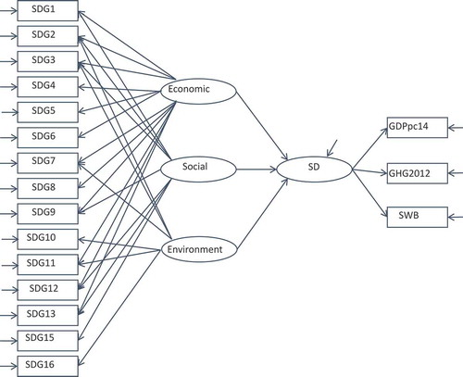

Figure-1

The ellipses in the middle of the path diagram (with the arrows) represent the structural model, which reveals the causal relationship between the latent factors (SDGs underlying pillars and sustainable development).

The three underlying pillars of sustainable development are represented by the latent variables: economic, social and environment (left-hand side ellipses). The causal impact of these three latent variables on the latent sustainable development variable (right-hand side ellipse) is estimated in the structural model.

SEM models have been widely used in economics (for a review refer to Tarka ([2018](https://www.tandfonline.com/doi/full/10.1080/13504509.2019.1692316))). A large body of literature present SEM as the prime language of causal analysis for both linear and nonlinear analyses (Pearl [2012](https://www.tandfonline.com/doi/full/10.1080/13504509.2019.1692316); Bollen and Pearl [2013](https://www.tandfonline.com/doi/full/10.1080/13504509.2019.1692316)).

The structural model that corresponds to [Figure 1](https://www.tandfonline.com/doi/full/10.1080/13504509.2019.1692316#F0001) and measures the causal relationship between the underlying pillars of SDGs and sustainable development can be expressed in the matrix form as follows:

x=Λ xξ+δ, (1)

y=Λyη+δ, (2)

η=Γξ+ς, (3)

where *x* and *y* are the indicator vectors of latent factors, namely, *x* includes the SDGs on the left-hand side of the path diagram and *y* represents the matrix of measures of sustainable development on the right-hand side. *η* is latent sustainable development and *ξ* includes latent factors (pillars) economic, social and environment. Λ*x* and Λ*y* are factor loadings which connect the latent factors and the observed indicators. The Γ coefficients indicate the causal relations between the latent factors, whereas *δ, ε* and *ς* are the error terms associated with the measurements.

The model is estimated by the Maximum Likelihood estimation method. The Maximum Likelihood (ML) approach estimates the unknown parameters in the model by minimizing the fit function, where *k* is the number of indicators, *S* and Σ are the sample and model implied variance and covariance matrix, respectively. This fit function assumes that the observed indicators have a multi-normal distribution.

**Findings:**

Quantifying SDGs require data and data in the developing countries is often remarkably poor and often missing. In fact, there is not a single five-year period since 1990 where countries have enough data to report on more than 70% of MDG progress (United Nations [2014](https://www.tandfonline.com/doi/full/10.1080/13504509.2019.1692316)).

Child mortality is widely assumed to have the best reported data, yet of the 161 developing countries, only 136 have data on it (Rodr´ıguez-Pose and Samuels [2015](https://www.tandfonline.com/doi/full/10.1080/13504509.2019.1692316)). Even where comprehensive data exists, certain groups are missing, such as ethnic minorities or indigenous populations and slum-dwellers.

The SDG Dashboards report (Sachs et al. [2016](https://www.tandfonline.com/doi/full/10.1080/13504509.2019.1692316)) identifies 77 indicators for 149 countries to measure SDGs based on five quality criteria for data selection, namely, global relevance and applicability to a broad range of country settings; statistically reliable data; availability for most recent years; best available data derived from official national and international sources; and good data coverage.

While there is no ideal and strict approach to data availability, Sachs et al. balance their data on two key decisions: using only actual published data, and including as many countries as possible. Data sources include the World Development Indicator database (World Bank [2016](https://www.tandfonline.com/doi/full/10.1080/13504509.2019.1692316)), the Human Development Report (United Nations Development Programme[2015](https://www.tandfonline.com/doi/full/10.1080/13504509.2019.1692316)), and OECD Statistics (OECD [2016](https://www.tandfonline.com/doi/full/10.1080/13504509.2019.1692316)), etc. They include indicators for which 80% of the data is available for countries with population greater than 1 million. We begin with this dataset as the base for our analyses.

The variables have also been scaled in the same direction. For instance, if the amount of untreated sewage decreases, it is a positive development, whereas if the number of school-going children decline, it has a negative impact on development. The variables are scaled, such that increase in it implies a positive impact on SDG and a decline implies a corresponding negative impact on SDGs.

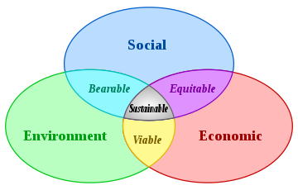

Figure-2

The sustainable development (right-hand side latent variable in [Figure 1](https://www.tandfonline.com/doi/full/10.1080/13504509.2019.1692316#F0001)) is measured by three indicators, namely, GDP per capita in 2014 (economic), greenhouse gas emissions equivalent in 2012 (environment) and subjective well-being in 2014 (social). Subjective well-being consists of three components: cognitive evaluations of one’s life, positive emotions (joy, pride), and negative ones (pain, anger, worry) (OECD [2013](https://www.tandfonline.com/doi/full/10.1080/13504509.2019.1692316); Helliwell [2016](https://www.tandfonline.com/doi/full/10.1080/13504509.2019.1692316)). It thus broadly captures the state of well-being that includes experiencing pleasant emotions, low levels of negative moods, and high life satisfaction.

**Limitations:**

Importance of Sustainable Development Goals (SDGs):

• Around 800 million people still live in extreme poverty and suffer from hunger, with fragile and conflict-torn states experiencing the highest poverty rates.

• Between 2008 and 2012, 144 million people were displaced from their homes by natural disasters, a number predicted to rise as the planet warms, bringing more extreme weather and rising seas.

• Water scarcity affects 40 percent of the global population and is projected to increase.

• Some 946 million people still practice open defecation.

• Gender inequality persists in spite of more representation for women in parliaments and more girls going to school.

If we meet the SDGs, the world will improve:

• End poverty and hunger everywhere.

• Combat inequalities within and between countries.

• Build peaceful, just and inclusive societies.

• Protect human rights and promote gender equality and the empowerment of women and girls.

• Ensure lasting protection of the planet and its natural resources.

• Create conditions for sustainable, inclusive and sustained economic growth, shared prosperity and decent work for all.

**Challenges to Sustainable Development Goals (SDGs):**

The Sustainable Development Goals (SDGs) which aim to eradicate

poverty and inequalities and spur economic growth while respecting

planetary boundaries. Reaching consensus on global goals that include

responsibilities for all countries is certainly worth a celebration. But these

goals are meant to be the bread for daily implementation, not cake for

special occasions. So, there are four important key challenges await

world leaders upon returning home. These are as follows:

**1. Involve the Whole of Government:**

Goals need to be embraced across ministries and integrated into national planning and policies to deliver the integrated vision embedded in the SDGs. Some objectives can serve multiple purposes investing in education will also help gender equality and health. Moreover, a coherent, coordinated approach to implementation is not just needed in developing countries. Leaders in developed countries will need to address poverty and inequalities at home and curb the cross-border impacts of their consumption and production patterns, which contribute to freshwater scarcity, deforestation, soil degradation, biodiversity loss and climate change and make poverty eradication harder to achieve.

**2. Engage All Sectors of Society:**

Transparency, participatory decision making and mobilizing the strength and innovation of local governments, the private sector and civil society are essential to implement the SDG agenda. We know from the Open Government Partnership that multi-stakeholder initiatives can change lives through citizen engagement. Leaders must now make sure it happens across all SDGs.

**3. Buy-in by Financial Institutions:**

Even when made a national priority, implementation of the SDGs will require significant resources: public and private, national and international, concessional and non-concessional. Domestic resources will dominate the resource envelope for implementation in all countries except LDCs, reinforcing the importance of getting national policies right. Financial institutions such as the World Bank, regional development banks and new development finance institutions such as the Asian Infrastructure Investment Bank can play a key role by aligning their portfolios with the SDGs and in stimulating private finance.

**4. Make Stakeholders Accountable:**

Reaching the SDGs will require collaboration, coordination and coherence within governments and engagement with a multitude of partners beyond national governments. As an intergovernmental system, the United Nations is only able to track progress of sovereign member states, based on voluntary progress reports. When national leaders implement the right to environmental transparency, including citizens in decision making so they can seek accountability and justice, ecosystems that are better-managed and protected will result.

**Map of Sustainable Development Goals (SDG) measure**. This map is based on the Sustainable Development Goals scores as estimated by the left-hand side measurement model in [Figure 1](https://www.tandfonline.com/doi/full/10.1080/13504509.2019.1692316#F0001).The scale moves from low SDG scores (red) to high SDG scores in blue. Gray color shows that the score cannot be calculated due to **missing data**.

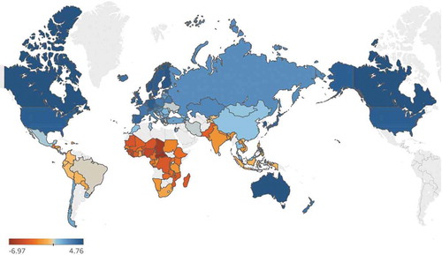

Figure-3

Biggest limitation in research is the acute shortage and unreliability of data available in poor countries.

**Implications**

Sustainable development is largely about people, their well-being, and equity in their relationships with each other, in a context where nature-society imbalances can threaten economic and social stability. Because climate change, its drivers, its impacts and its policy responses will interact with economic production and services, human settlements and human societies, climate change is likely to be a significant factor in the sustainable development of many areas. Simply stated, climate change has the potential to affect many aspects of human development, positively or negatively, depending on the geographic location, the economic sector, and the level of economic and social development already attained. Because settlements and industry are often focal points for both mitigation and adaptation policy-making and action, these interactions are likely to be at the heart of many kinds of development-oriented responses to concerns about climate change.

In most cases, with the Arctic being a notable exception, these connections between climate change and sustainable development will only *begin* to emerge in the next decade or two (e.g., during the period embraced by the Millennium Development Goals) as a result of significant impacts that can be attributed to climate change. But industry, settlements and societies will be important foci of mitigation actions and adaptations involving land uses and capital investments with relatively long lifetimes. In the meantime, however, actions that address challenges of climate variability, including extreme events, contribute to environmental risk management as well as reducing possible impacts of climate change.

The most serious issues for sustainable development associated with climate-change impacts on the subjects of this chapter are: (a) threats to vulnerable regions and localities from gradual ecological changes leading to impact thresholds and extreme events that could disrupt the sustainability of societies and cultures, with particular attention to coastal areas in current storm tracks and to economies and societies in polar areas, dry land areas and low-lying islands, and (b) threats to fragile social and environmental systems, both from abrupt climate changes and thresholds associated with more gradual climate changes that would exceed the adaptive capacities of affected sectors, locations and societies. Examples include effects on resource supply for urban and industrial growth and waste management (e.g., flooding). As a very general rule, sensitivities of more-developed economies to the implications of climate change are less than in developing economies; but effects of crossing thresholds of sustainability could be especially large in developed economies whose structures are relatively rigid rather than adaptable. In the case of either developed or developing countries, social system inertia may delay adaptive responses when 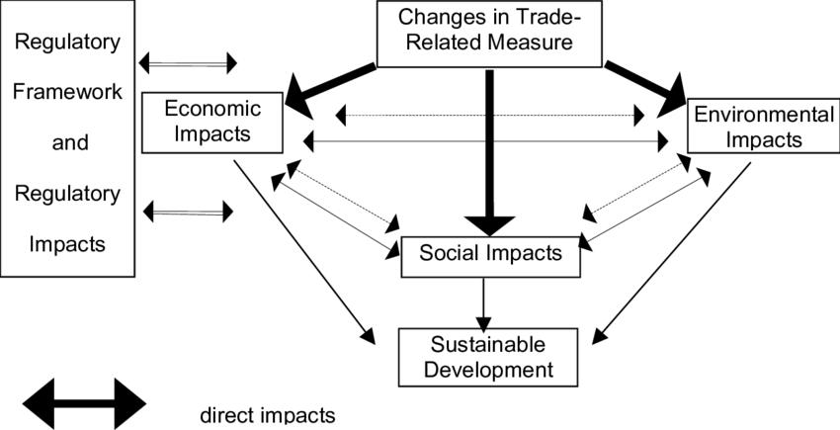experienced climate change is gradual and moderate.

The World Bank recommends that countries that want to develop their knowledge-based economies should focus and concentrate all their efforts on four major areas:

**• Education and Training** – an educated and skilled population.

**• Information infrastructure** – a dynamic information infrastructure: ranging from radio to the internet.

**• Economic incentive and institutional regime** – a regulatory and economic environment that enables the free flow of knowledge, supports investment in Information and Communications Technology (ICT)and encourages entrepreneurship.

**• Innovation systems** – a network of research centers, universities, think tanks, private enterprises and community groups that can tap into the growing stock of global knowledge, assimilate and adapt it to local needs, and create new knowledge.

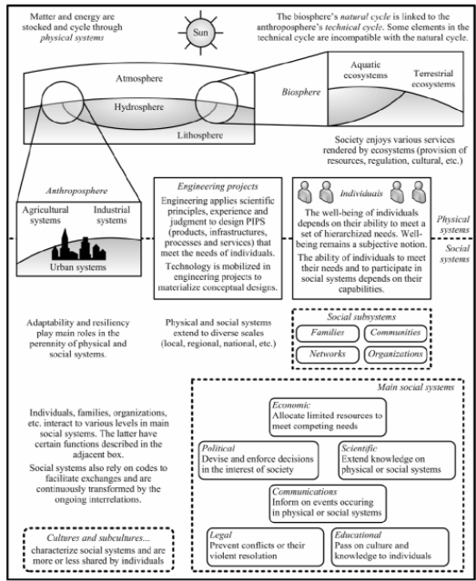

Effective decision-making in engineering for sustainable development is only possible when we know what is needed or wanted – the framework of the problem, issue or challenge to be tackled. This should be identified as clearly as possible, including identifying any legal requirements and constraints. We should use teamwork and assistance of immediate colleagues to improve problem definition. It is important to recognise that many engineering challenges are driven by what people want to have – such as even better motor cars – rather than just what they need – a means of transport. In addition, ‘wants’ are often characterised as ‘needs’ when they are in fact just perceived needs, and a more modest solution may ultimately be acceptable.

The Sustainable Development Goals make the co-creation of new knowledge among countries, state institutions and non-state actors a must, and indeed for most countries, achieving the goals may well depend on it. The proposed universality of the SDGs underscores the reality that most countries acknowledge.

**Originality Value**

This paper demonstrates why the framework is not only of interest to engineers, but also to decision makers involved in engineering projects or technological development. The framework could be used, for example, by managers in organizations concerned with social responsibility or by policy makers implementing sustainable development strategies.

The contribution of a project towards sustainable development can be analysed with a wide variety of tools such as life cycle assessment, impact assessment, stakeholder analysis, environmental valuation, etc. (Gagnon and Leduc, 2006). The tools selected to analyse a particular project need to be positioned on the framework to clearly identify which component or interaction they intend to evaluate. Any selected tool should fit in a logical manner within the framework.

This encompasses the processes that are relevant for decision-makers involved in engineering projects or technological development. Even though the sustainability framework exposed in this paper was developed in a structured manner, only a few of all conceivable interactions between engineering, society and environment could be discussed. The sustainability framework therefore needs to be expanded upon by professional engineers or professors in the field of engineering in order to meet their particular needs. Only then will it capture the entire complexity of every particular situation and truly assist users in their activities.

In Conclusion sustainable development comprises of the fusion of efficient working of Economy Ecology and Society.

This paper elaborates upon the synergy of these three aspects of sustainable development.

**Sustainability = Economy + Ecology + Society**

**Reference**

1. **Herkert, J.R. (1998)** Integrating engineering ethics and public policy: three examples, in Luegenbichl, H., Neeley, K. and Ollis, D.F., eds., Liberal Education in 21st Century Engineering, Peter Lang, New York (forthcoming).
2. **World Commission on Environment and Development (1987)** Our Common Future (The Brundtland Report). Oxford University Press, Oxford.
3. **French, H.F. (1995)** Forging a new global partnership, in Brown, L.R. et al., State of the World 1995, W.W. Norton & Company, New York:
4. **President’s Council on Sustainable Development**, World Wide Web site: http://www.whitehouse.gov/pcsd
5. **Carroll, W.J. (1993)** World Engineering Partnership for Sustainable Development. Journal of Professional Issues in Engineering Education.
6. **Engineering Education for Sustainability**<https://www.sciencedirect.com/science/article/pii/S1877042813042936>
7. **Climate Change 2007: Working Group II: Impacts, Adaptationand Vulnerability**

<https://archive.ipcc.ch/publications_and_data/ar4/wg2/en/ch7s7-7.html>

1. **Engineering Education for Sustainable Development**

<https://sustainabledevelopment.un.org/content/documents/970027_Kelly_Engineering%20Education%20for%20Sustainable%20Development.pdf>

1. **Engineers Australia (2005)** Engineers Australia’s Sustainability Charter<http://tinyurl.com/engaustsd>